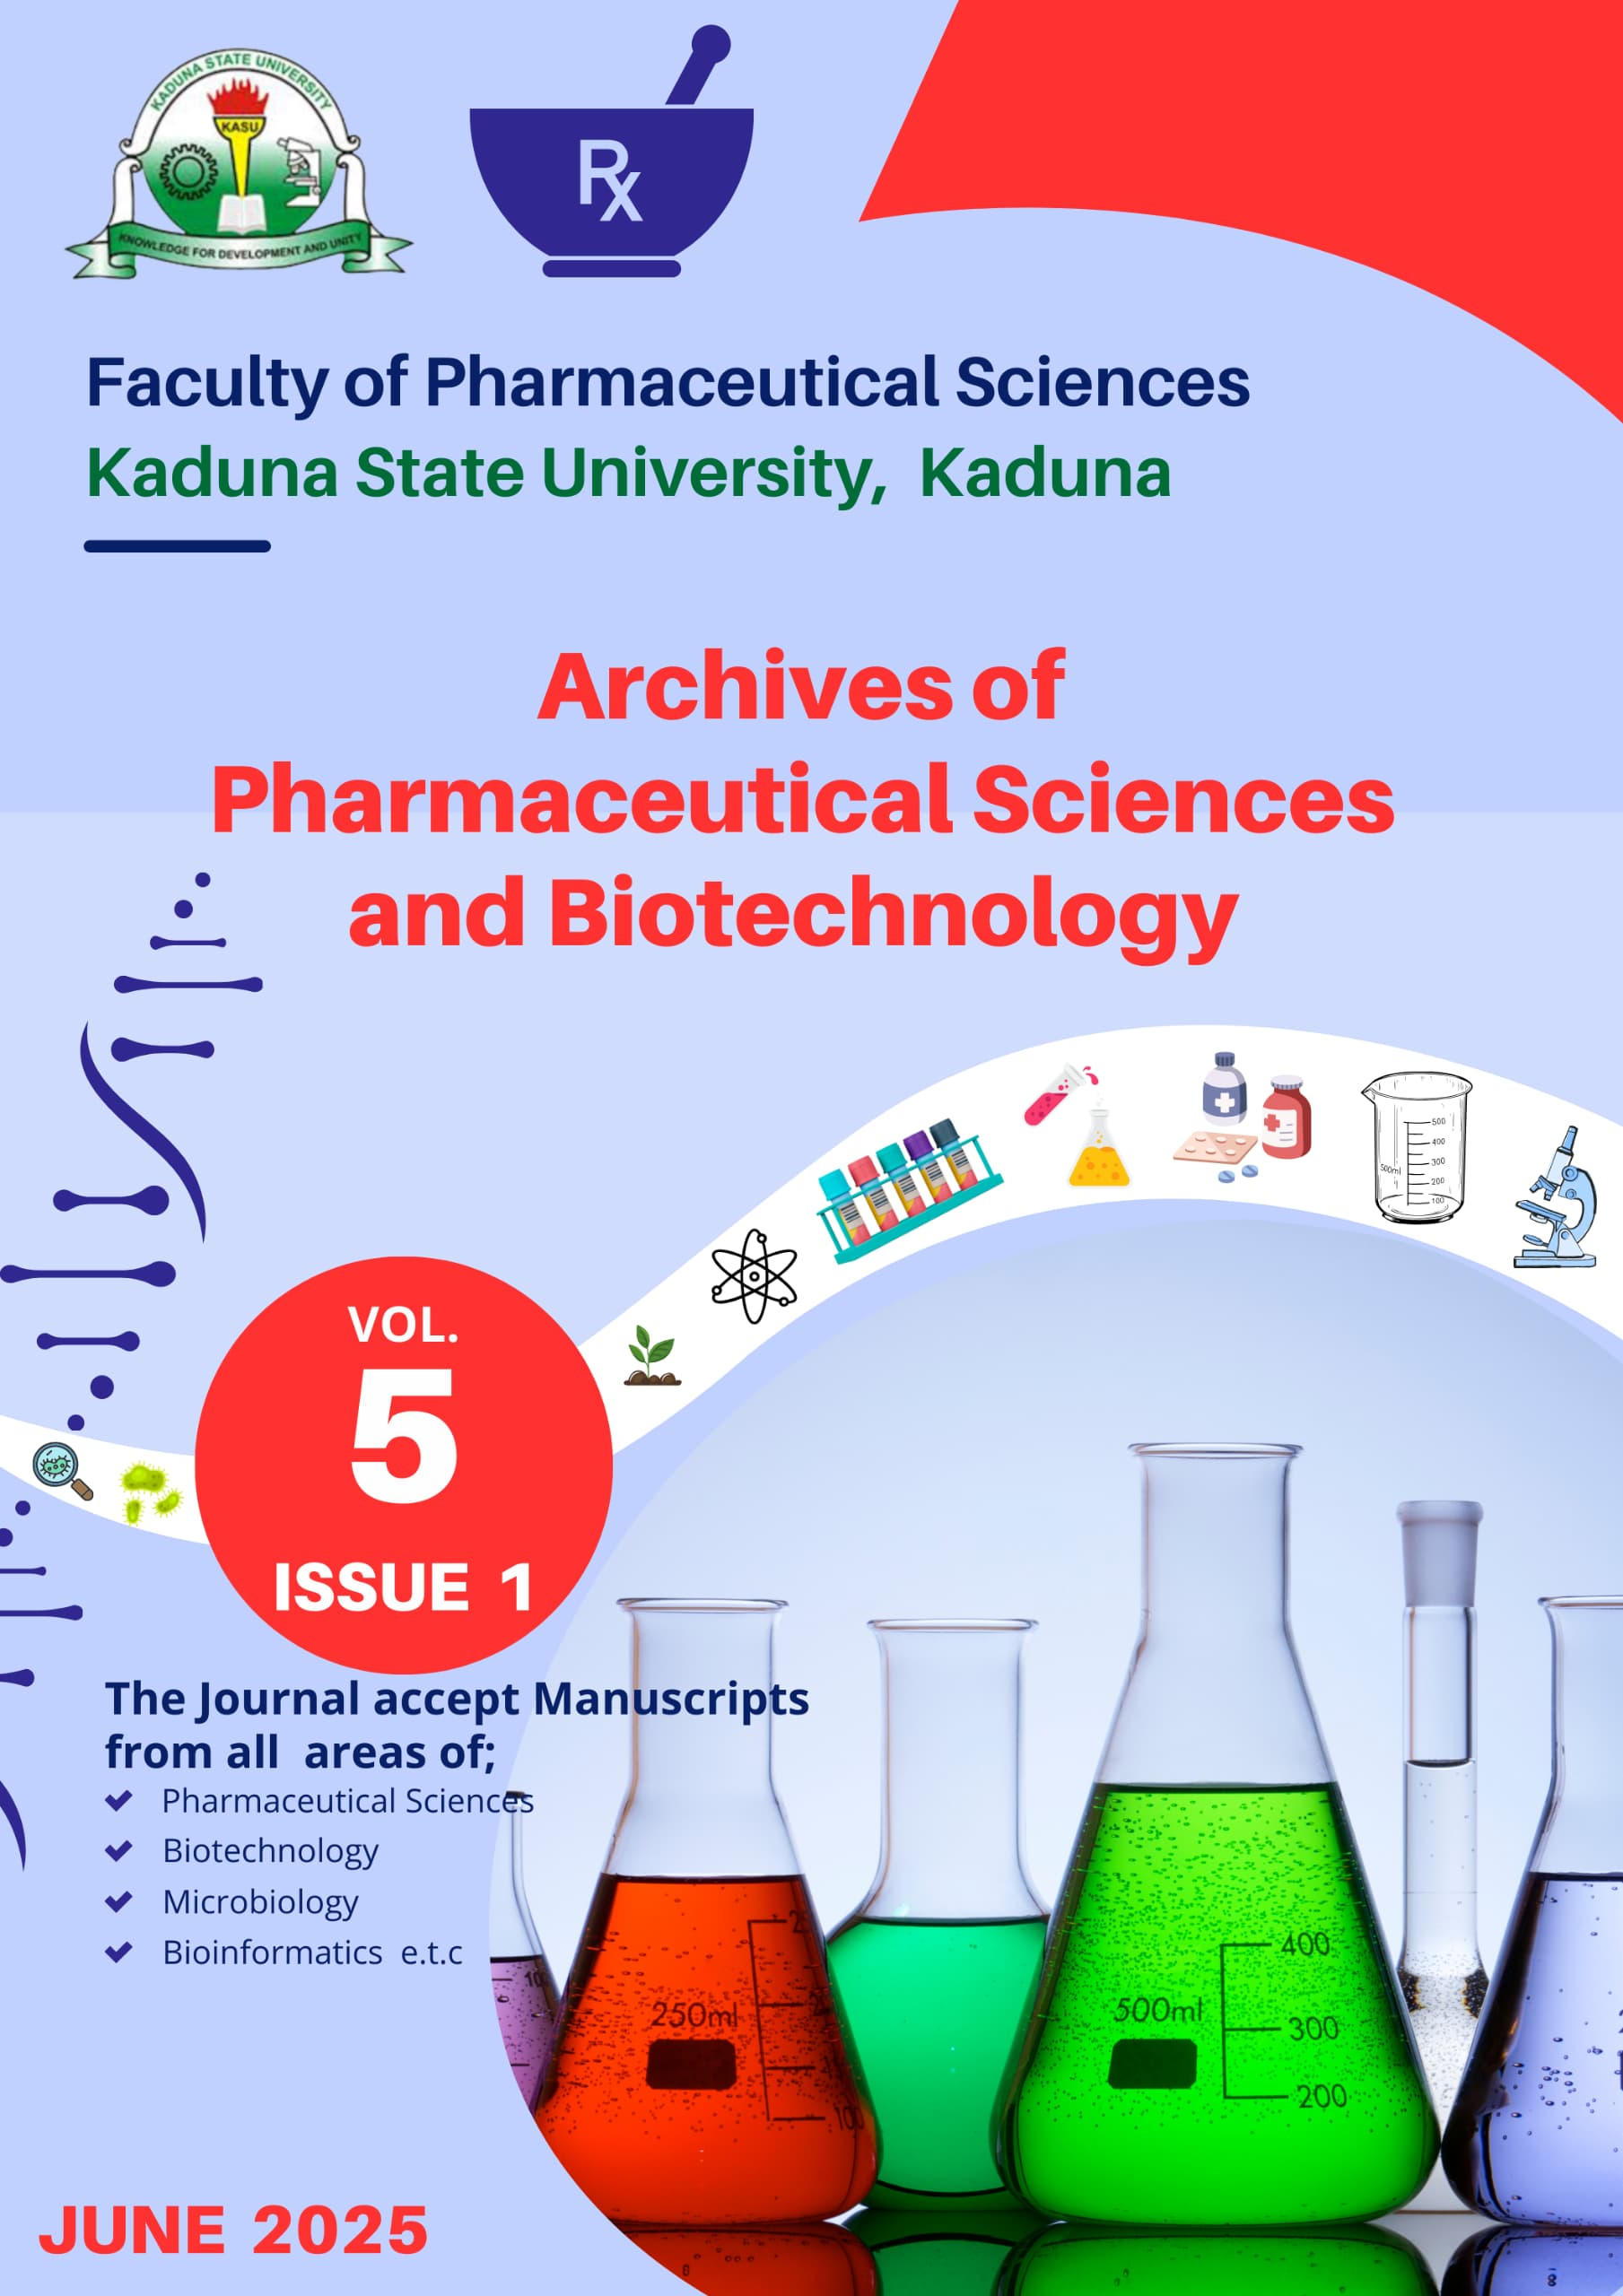

ARCHIVES OF PHARMACEUTICAL SCIENCES AND BIOTECHNOLOGY JOURNAL
VOLUME 5 ISSUE 1, JUNE 2025
ISSN 2971 – 611X
©ALL RIGHTS RESERVED
Published by the Faculty of Pharmaceutical Sciences, Kaduna State University, Kaduna
Acetylation of Gum from Stem Bark Grewia mollis juss. for use as a Disintegrant in Tablet Formulation

⃰ Ubangida, M.S.S. ¹,Apeji, Y.E.², Isah, A.B.² ,Babawuro, A.A. ², Aliyu, Y. ²and Danraka, R.N.²
¹ Department of Pharmaceutics and Industrial Pharmacy, Faculty of Pharmaceutical Sciences, Kaduna State University, Kaduna, Nigeria.
² Department of Pharmaceutics and Industrial Pharmacy, Faculty of Pharmaceutical Sciences, Ahmadu Bello University, Zaria, Nigeria.
*Corresponding author: salihumsubangida@gmail.com /+2348030490137
ABSTRACT
Introduction: Gums are polysaccharides of natural origin that have been used traditionally as binders in the formulation of tablets by wet granulation. Grewia polysaccharide gum as a natural resource could be used as an excipient in the pharmaceutical industry to reduce the costs of pharmaceutical products. It may provide a suitable alternative to the synthetic counterparts which are expensive and mostly imported.¹² Interest in Grewia polysaccharide gum as a pharmaceutical excipient has been on for more than a decade now.¹³This growing interest is informed by the viscous property of the gum extracted from the inner stem bark of the Grewia mollis plant. ¹²
Aim: This research aimed at acetylating gum from stem bark of Grewia mollis Juss (GG) using acetic anhydride as the acetylating agent.
Methods: GG 75 g was mixed with acetic anhydride 139 ml (150 g, ρ = 1.08 g/mL) in a ratio of 1:2. Sodium hydroxide 5.0 % w/v was used as an oxidizing agent and the mixture was stirred for 2 – 3 mins. After which 50 g of the acetylated gum was sized reduced in a mortar and dispersed in 100 mL of water (distilled water), then bleached using 20 mL of sodium hypochlorite solution (10 % ^{w}/_{v)} for 1 h to obtain the buff colour (light brownish yellow).
Results: The yields of the gums were found to be 58.5, 80.3, and 60.0 % for GG (Grewia Gum), AGM (Acetylated Grewia Gum), and BAGG (Bleached Acetylated Grewia Gum) respectively. The pH values for the gums were 4.83, 4.95, and 4.01 for GG, AGM, and BAGG respectively. The swelling capacities were 1.59 ± 0.00, 2.90 ± 0.01, and 2.80 ± 0.00 respectively for GG, AGM, and BAGG. Moisture contents were 0.54 ± 0.01, 0.13 ± 0.01, and 0.12 ± 0.01 for GG, AGM and BAGG respectively. The LD ₅₀ values of both the native and derivatized gums were both greater than 5000 mg.
Discussion: These findings revealed that the product yields may be dependent on the species of Grewia processed as well as the processing conditions. Also, the difference in the yield between the AGM (80.3 % ^{w}/_{w}) and BAGG (60.0 % ^{w}/_{w}) was due to the lost for materials in the course of bleaching. The pH value of BAGG mucilage would be relatively unchanged if samples are stored at 25 º C to 45 º C, which is desirable for pharmaceutical excipients that may be subjected to elevated temperatures during processing, handling or storage. The BAGG samples are preferably stored in air-tight containers under low humidity. The swelling index of our studied BAGG powder was greater than that of Grewia venusta evaluated by Alobo and Arueya (2017) (2.80 ± 0.00 % vs. 1.7 ± 0.1%). This implies that BAGG-containing dosage forms exhibit relatively superior bioadhesive and sustained drug release properties.
Conclusion: The results of this study had been able to establish that chemical modification through acetylation of GG improved the physicochemical properties of the gum which invariably increases its emulsifying capacity that further increases its swelling index and solubility thereby opening prospects for extending the applications of the native gum.

Keywords: Acetylation, Bleaching, Characterization, Grewia gum (GG), Organoleptic properties.

INTRODUCTION
The intrinsic structures and properties of gums - including non - ionic, anionic, and cationic gums - make them have extensive applications in various areas. However, these raw gums also possess some drawbacks and cannot meet all application requirements for some special purpose. Hence, the need for modification of these gums with active small molecules. Chemical modification provides an efficient route not only for removing such drawbacks but also for improving physicochemical properties such as solubility, viscosity and swelling index and to introduce new properties for different applications. A number of modifications via chemical treatment can be introduced resulting in products and/or derivatives suitable for specific applications in the food and pharmaceutical industries. ¹
These derivatives do not only bring the favourable properties due to the introduction of functional groups, but also keep the intrinsic advantages of gums to the greatest degree. Generally, the chemical functionalization of gums mainly includes the acetylation (esterification), carboxylation, etherification, and cross-linking reactions of hydroxyl groups. ¹⁶
Chemical modification through acetylation generally increases the emulsifying capacity which further increases swelling index and solubility. ¹ Acetylation, a chemical means of attaching pendant acetic anhydride groups to produce acetylated gum, is technically simple, has low cost of chemical reagents and wide range applications. ¹ The acetylated gum is produced by the esterification of native gum with acetyl groups. ² The efficiency of the reaction is affected by factors such as reagent concentration, reaction time, pH, and presence of catalyst and gum source. The functional properties of the gum acetate will depend on the number of acetyl group incorporated to the sugar unit of gum molecules. ¹
The superior solubility and swelling index of acetylated gum compared with the native gum may be due to the presence of hydrophilic substituting groups (CH₃C=O) which allow the retention of water molecules because of their ability to form hydrogen bonds. ¹⁵
Grewia polysaccharide gum as a natural resource could be used as an excipient in the pharmaceutical industry to reduce the costs of pharmaceutical products. It may provide a suitable alternative to the synthetic counterparts which are expensive and mostly imported.¹² Interest in Grewia polysaccharide gum as a pharmaceutical excipient has been on for more than a decade now. ¹³ This growing interest is informed by the viscous property of the gum extracted from the inner stem bark of the Grewia mollis plant. ¹² Hence the need for its acetylation via chemical modification to improve its physicochemical properties and open prospects for extending the application of the raw gum.

MATERIALS AND METHODS
Materials
Extracted Grewia gum GG, Acetic anhydride, Sodium hydroxide 5.0 % w/v, Ethanol 95 %, Sodium hypochlorite solution (10 % ^{w}/_{v)} (M & B Laboratory Reagent, England), Distilled water, Stirrer.

Methods
Acetylation of Grewia mollis:
The acetylation of Grewia mollis was carried out using the method described by Biswas et al. (2008). Here, a mixture of the gum, Grewia mollis to acetic anhydride ratio of 1:2 was employed. Sodium hydroxide 5.0 % w/v was used as an oxidizing agent. About 75 g of GG powder was suspended in 139 mL (150 g) of acetic anhydride (ρ = 1.08 g/mL) and the mixture was stirred. Sodium hydroxide (5 % w/v) was added to the suspension and stirred for 2-3 mins. The mixture was then placed in an oven for 15 mins. After which, the mixture was transferred to a beaker containing 100 mL of ethanol, stirred for 30 mins and filtered. The residue was dissolved in water and repeated with ethanol, after which was filtered and finally dried at 60 ⁰ C in the oven overnight. The percentage yield was then calculated.

Bleaching of Acetylated Grewia Gum:
The method adopted by Klunklin et al. (9) was used. Here, 50 g of the acetylated grewia gum was sized reduced in a mortar. The ground gum was dispersed in 100 mL of water (distilled water), then bleached using 20 mL of sodium hypochlorite solution (10 % ^{w}/_{v)} for 1 h to obtain the buff colour (light brownish yellow). The bleached gum was then filtered and washed severally with excess distilled water. Finally, the solid (bleached-acetylated gum) was dried at 25 º C for 2 days and the % yield was calculated.

Organoleptic Properties:
The colour, taste, odour and texture of the AGM and BAGG were examined and the results were documented.

Toxicity Studies:
Five mice each weighing 20 g were randomly selected from animal houses in the Department of Pharmacology and Therapeutics, marked for individual identification and kept in their cages for at least five days before dosing for acclimatization to the laboratory conditions. The mice were fasted before dosing and weighed. A dose of 2000 mg was administered using an oral cannula and observed for signs of toxicity for three days. Then a higher dose of 5000 mg/kg body weight was also administered using 500 mg of the AGM and BAGG in 10ml of solution respectively. Treatment of the mice at the next higher dose was delayed until we were confident of the survival of the previously dosed mice. Attentions were directed to the observation of signs of toxicity such as tremors, convulsions, salivation, diarrhoea, lethargy, and coma, throughout 24 hours for two weeks (14 days), and mortality observed thereafter.

Bulk and Tapped Densities:
Ten (10) g quantity each of the AGM and BAGG were placed into a clean 50 ml measuring cylinder and the volume, V0 (bulk volume), occupied by each of the gums without tapping was noted. The cylinder was tapped several times on a hard table top and tapped volumes was recorded. The bulk and tapped densities were calculated as the ratio of mass to volume. The experiment was repeated in triplicates and the average obtained.

Carr’s Compressibility Index and Hausner’s ratio:
This was the percentage difference between the tapped density and the bulk density also referred to as the compressibility index. Hausner’s ratio was the ratio of the tapped density to bulk density.

Angle of Repose
A clean glass funnel was clamped on a retort stand such that the perpendicular height of the tip of the funnel was 10 cm from the flat table surface with a clean sheet of paper. 10 g each of the gum samples was poured into the funnel, with the opening of the funnel blocked with a cotton wool, after which it was removed and a gum heap formed. The height of the gum sample was measured as H (cm). The diameter of the circumference of the heap was divided to give the radius R and the angle of repose was calculated using the eqtn 1;
Tan Ø = h / r ………………………… Eqtn 1
Where Ø = angle of repose, h = height of the gum heap, and r = radius of heap base.

Characterization of AGM and BAGG:
Percentage Yield
The percentage yields each of the AGG and BAGG was calculated as the weight of the gum obtained with respect to the original weight of the gum from which it was extracted (i.e. total weight of the plant collected). It was calculated using the equation 2 below:

$$Yield \left(\%\right)=\frac{\begin{aligned} \\ Total weight of the \\ gum extracted \left(g\right)\end{aligned}}{\begin{aligned} Original weight of the \\ gum from which it was extracted\left(g\right)\end{aligned}} X 100………….….Eqtn 2$$

pH measurement
The pH each of the AGM and BAGG solution was measured using a pH meter (Mettler Toledo) with a microprocessor. A 1 % dispersion each of the gum was prepared, and the pH was taken at room temperature (25 º C). This was performed in triplicates and the average was obtained.

Viscosity
The apparent viscosity each of the AGM and BAGG was determined using a Brookfield Viscometer (Model RVF, Stoughton, MA). The gum slurry (5%) was placed in a boiling bath for 15 minutes and then cooled to 22 ⁰ c. Cold paste viscosity was determined using a spindle at 25 ⁰C.

Moisture Content
Determination of the moisture content each of the AGM and BAGG was carried out with the aid of a moisture content analyzer (OHAUS MB 45). A 1 g sample each of the gum was weighed with the aid of a weighing balance (Mettler Toledo ME 303E) and placed in the moisture content analyzer that was set at 100 ° C for 10 min. The moisture content was performed in triplicates and the average was obtained.

$Moisture content \left(\%\right)= \frac{weight of wet mass-weight of dry mass}{weight of dry mass}×100…………3.2$Swelling Capacity
The swelling capacity was determined according to the method adopted by Babu and Parimalavalli (2012) by making a dispersion of 1 g each of the AGM and BAGG in 10 mL of distilled water in a pre-weighed centrifuge tube. This was placed in a water bath (Karl Kolb Sci. Co, Germany) equilibrated at 90 ° C and the sample was allowed to stand with agitations for 30 min. The swollen gum was cooled to 25 ° C, centrifuged at 1,500 rpm for 10 min, and the supernatant was discarded. The weight of the tube with the swollen gum gel was further weighed and the swelling capacity calculated using equation 3.

$$Swelling Capacity= \frac{weight of swollen granules}{weight of dry sample}…………Eqtn 3$$

FT-IR Analysis
IR scan of each of AGM and BAGG was collected over a range of 4000 – 650 cm⁻¹ using a Cary 630 FT-IR Spectrometer (Agilent Technologies, USA). The sample was subjected to an average of 32 scans at a nominal resolution of 8 cm⁻¹, employing a background spectrum of gold. The Cary 630 Micro Lab PC software was used for data collection and analysis.

Scanning Electron Microscopy (SEM)
The scanning electron microscope (JOEL-JSM 7600F, Germany) was used to determine the morphology, shape, and surface characteristics each of the gums. The sample was prepared by sprinkling the dispersed gum onto double-sided adhesive carbon conductive tape which was mounted on a microscopic stub of copper. Then the sample was sputter-coated with gold using an ion sputtering device of the equipment.
The elemental contents were analysed by inductively coupled plasma-optical emission spectroscopy (ICP-OES) and ICP-mass spectrometry (ICP-MS), in the microwave assisted digested samples after validating the applied methods via quality assurance parameters

RESULTS
Percentage Yields and Organoleptic Properties of AGM and BAGG:
The organoleptic properties of AGM and BAGG and their yields are as presented in Table I. the gums were found to be rough, odourless and bland in taste. The percentage yields of AGM and BAGG were found to be 80.3 % and 60.0 % respectively, with LD₅₀ of each greater than 5000 mg/kg.

Table I: Percentage Yields and Organoleptic Properties of GG, AGM and BAGG
Properties | GG | AGM | BAGG
Percentage yield (%)  pH ( 25 º C, 45 º C)  Viscosity  50 rpm  100 rpm | 58.5  4.83, 4.43  12.82  11.67 | 80.3  4.95, 4.55  -  - | 60.0  4.41, 4.01,  12.07  11.42
Colour | Brown | Coffee | Buff
Taste | Bland | Bland | Bland
Odour | Odourless | Odourless | Odourless
Texture | Rough | Rough | Rough
Toxicity studies | Non-toxic, LD ₅₀ > 5000 mg | - | Non-toxic, LD ₅₀ > 5000 mg

Key: LD₅₀ = Lethal dose, GG = Native Grewia Gum

Physicochemical Properties of GG, AGM and BAGG:
The physicochemical properties of the native and acetylated gums are presented in Table II.

Table II. Physicochemical Properties of GG, AGM and BAGG
Material | BD (g/mL) | TD (g/mL) | HR (%) | CI (%) | AoR (°) | SC | MC (%)
GG | 0.14 ± 0.00 | 0.20 ± 0.00 | 1.43 ± 0.04 | 30.03 ± 2.02 | 49.70±1.94 | 1.59 ± 0.00 | 0.54 ± 0.01
AGM | 0.63 ± 0.00 | 0.67 ± 0.00 | 1.29 ± 0.06 | 22.50 ± 3.54 | 47.84±0.84 | 2.90 ± 0.01 | 0.13 ± 0.01
BAGG | 0.63 ± 0.00 | 0.70 ± 0.00 | 1.34 ± 0.13 | 25.00 ± 7.07 | 46.17±1.11 | 2.80 ± 0.00 | 0.12 ± 0.01
Values are presented as mean of triplicate readings ± standard deviation

Key: GG – Grewia mollis gum, AGM – Acetylated Grewia mollis, BAGG – Bleached Acetylated Grewia gum
Physicochemical Properties of GG and BAGG Granules:
The physicochemical properties of GG and BAGG Granules are presented in Table III respectively.

Table III. Physicochemical Properties of GG and BAGG Granules:
Material BD (g/ml) TD (g/ml) HR (%) CI (%) AoR (°)
GG – A 0.28 ± 0.00 0.39 ± 0.00 1.21 ± 0.03 15.00 ± 2.65 30.05 ± 0.70
BAGG - A 0.77 ± 0.00 0.89 ± 0.03 1.16 ± 0.04 13.46 ± 2.72 24.83 ± 1.00
BAGG – B 0.77±0.00 0.91±0.00 1.18 ± 0.00 15.38 ± 0.00 23.35± 0.21
BAGG – C 0.80±0.00 0.93±0.03 1.16 ± 0.04 14.00 ± 2.83 23.25± 1.23
BAGG – D 0.83±0.00 0.93±0.03 1.12 ± 0.04 10.42 ± 2.95 30.01± 0.64
Values are presented as mean of triplicate readings ± standard deviation
Key: GG – Grewia mollis gum, AGM – Acetylated Grewia mollis, BAGG – Bleached Acetylated Grewia gum

FTIR Image of BAGG:
Figure 1 is the IR spectrum that shows the absorption spectrum of BAGG. There are slight changes in the spectra between native gum and acetylated gum. Although the acetylated gum retains the characteristics of the native gum, there is an introduction of a broad vibration band at 3400 cm⁻¹ on the spectra which is due to O-H stretch, and disappearance of sharp absorption bands at 1750 and 1800 cm⁻¹ respectively, which are due to the C=O stretches.
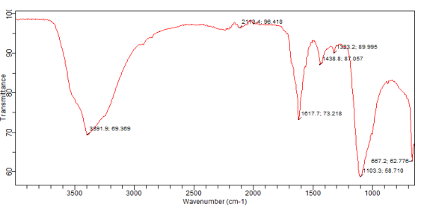
Figure 1: FT-IR Scan of BAGG

Scanning Electron Microscopy (SEM)
The SEM image of BAGG is as shown in Plate I (a, b and c). From the result, it can be seen that the structures assumed spheroidal, cuboidal and/or squamous shape(s), with a relatively smoother edge(s) at all magnifications.
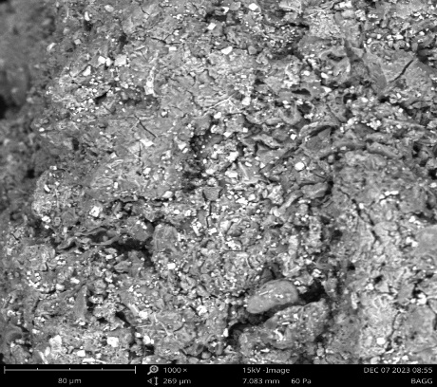
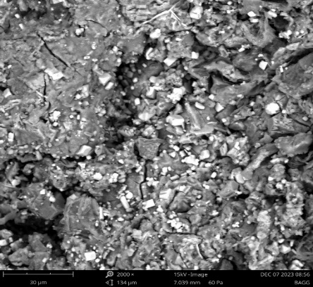
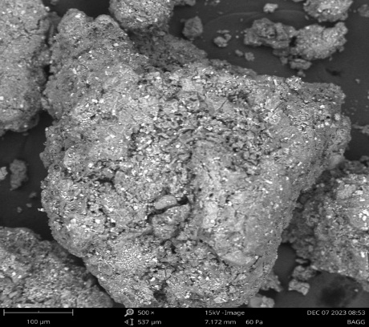
a) b) c)

Plate I: Scanning Electron Micrograph of BAGG at a) 500 ×, b) 1000 × and c) 2000 × Magnifications

Elemental Composition of BAGG Using SEM Analysis
The SEM image of particles of BAGG shows eleven elements with atomic concentration range of 0.00 to 34.89, as shown in Plate II. The highest of which is calcium and the lowest Titanium respectively.

Element Element Element Atomic Weight
Number Symbol Name Conc. Conc.
11 Na Sodium 19.83 13.62
12 Mg Magnesium 1.67 1.21
13 Al Aluminium 2.87 2.31
14 Si Silicon 2.54 2.13
15 P Phosphorus 1.09 1.01
16 S Sulfur 9.30 8.91
17 Cl Chlorine 32.55 34.47
19 K Potassium 0.44 0.51
20 Ca Calcium 29.15 34.89
22 Ti Titanium 0.00 0.00
26 Fe Iron 0.56 0.94
Plate II: Elements Found in the SEM Image of BAGG

Differential Scanning Calorimetry DSC
The DSC thermogram of BAGG is as shown in Figures 2. The BAGG thermogram shows an exotherm at about 32 ºC which drops at 45 ºC and then broadens over 180 ºC.
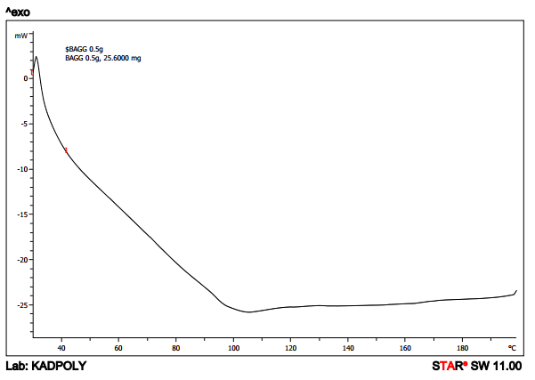
Figure 2: DSC Thermogram of BAGG

DISCUSSION
Grewia polysaccharide gum is a natural resource that could be used as an excipient in the pharmaceutical industry to increase in the production of pharmaceutical products. Grewia gum was successfully extracted from the stem barks of Grewia mollis by maceration in water at room temperature for 72 h and was acetylated using acetic anhydride. The product (BAGG) yield based on its dry weight was 60.0 % w/w, which was higher than 32.4% obtained by Nep and Conway (2010) that used heat and chemicals to treat their powdered stem barks. Alobo and Arueya also obtained a lower yield of 18% for their Grewia venusta samples as mucilage was collected immediately after immersion of the stem barks in water without heat treatment. Haile’s group reported product yield of 11.96% for Grewia ferruginea after soaking the stem barks in water at room temperature for 48 h. These findings revealed that the product yields may be dependent on the species of Grewia processed as well as the processing conditions. ¹⁵ Also, the difference in the yield between the AGM (80.3 % ^{w}/_{w}) and BAGG (60.0 % ^{w}/_{w}) was due to the lost for materials in the course of bleaching.
BAGG mucilage did not display temperature-dependent pH changes as the samples exhibited pH of 4.41 ± 0.1 and 4.01 ± 0.1 at 25 and 45 º C, respectively. These pH values were highly acidic comparable to that of Grewia venusta evaluated by Alobo and Arueya (2), with samples exhibiting pH between 5.17 and 5.80 at 25 º C and 45 º C respectively. These findings suggest that the pH value of BAGG mucilage would be relatively unchanged if samples are stored at 25 º C to 45 º C, which is desirable for pharmaceutical excipients that may be subjected to elevated temperatures during processing, handling or storage. ¹⁵
The BAGG sample exhibited its highest viscosity (12.07 mPas) at shear rate of 50 rpm, room temperature while the viscosity of 11.42 mPas was obtained for the sample at 100 rpm under acidic conditions, at 45 º C, indicating that the presence of acidic components as well as application of increased shear stress in a BAGG - containing formulation may decrease the overall viscosity of the dosage form. Also, alkaline materials can be incorporated into BAGG - containing formulations for viscosity enhancing effect. ¹⁵
BAGG was buff (reddish brown) in colour, odourless, and rough in texture. This colour is in agreement to similar Grewia samples evaluated previously. The powder particles were cohesive in nature due to their rough texture, with greater tendency to interlock than particles with smooth surfaces and these organoleptic properties affected their flowability. ¹⁵
The acute toxicity studies also known as single dose studies, were conducted to determine the short - term adverse effects of a drug or any substance when administered in a single dose, or in multiple doses over a period of 24 h in an animal species. It provides information on potential for acute toxicity in humans, an estimate of safe acute doses for humans and on doses that should be used in subsequent studies. ⁸ In this study, the LD₅₀ of the BAGG was found to be greater than 5000 mg/kg, since all the mice were able to survive after two weeks, and there was no mortality, hence the gum was said to be non-toxic and relatively safe for use in humans.
The angle of repose indicated the flowability of powdered material or a granular substance. Materials with angle of repose less than 20 ⁰ have excellent flow, 20-30 ⁰ have good flow, 30-34 ⁰, passable flow and greater than 40 ⁰ indicate very poor flow. ³ AGM with angle of repose of 17.84 ⁰, had excellent flowability, while BAGG with angle of repose of 26.17 ⁰ had good flow. The decrease in flowability of the bleached acetylated gum could be as a result of the decreased granule sizes of the gums, produced as a result of size reduction (communition) of the BAGG into fine powders. ^{15,1}
The presence of residual water in Grewia powder makes it susceptible to microbial attack after storage. Moreover, hygroscopic pharmaceutical products absorb moisture, resulting in caking of such products, limiting their dispersibility during reconstitution. ¹⁵ The moisture content of BAGG (0.12 ± 0.01 %), was within the Pharmacopeial limit of ≤ 15 % and less than that of similar Grewia samples previously studied by Nep and Conway 2010 and Alobo and Arueya (2017), (10.6 ± 2.0 % and 14 ± 0.01 %) respectively. Decreased level of water in a powder mass decreases the thickness of the adsorbed liquid layer as well as the strength of liquid bridges, thereby reducing the cohesiveness of the powder, and results in the reduction of agglomerates formation which enhances powder flow properties. Thus, Grewia gums are preferably stored in air-tight containers under low humidity. ¹⁵
Grewia mollis gum powder exhibited a bulk density and tapped density of 0.63 ± 0.00 and 0.67 ± 0.00 g/mL, respectively. These values are considered acceptable when compared with that reported by ¹⁵, with a bulk density and tapped density of 0.7 ± 0.1 and 0.8 ± 0.1 g/mL respectively, for Grewia mollis. Compressibility index and Hausner ratio are typically used to depict the flowability of powders. A free-flowing powder exhibits low compressibility index with improved stability and strength, with compressibility index [CI] values less than 15 % depicting good powder flow. ¹⁴ BAGG powder/sample displayed a CI value of 25.00 ± 7.07 %, suggesting moderate to poor flow properties for the powder. Hausner ratio (HR) is a function of the inter-particulate interactions and a value less than 1.25 depicted good flow properties. ¹⁴ BAGG also exhibited moderate to poor flowability as its HR values was 1.34 ± 0.13 %. The flowability of BAGG was similar but still better than that of the samples reported by Nep and Conway (2010), with the Grewia gum powder displaying passable flow, as CI and HR values were 25.2 ± 1.9 % and 1.30 ± 0.02 respectively. ¹⁵ This implied that on application of pressure, BAGG might not produce good compacts; but the addition of other tableting excipients and processing of the BAGG into granules could improve their compressibility (as shown in the Table III). ⁵
The rapid swelling of polymers in water is associated with the breakage of intermolecular hydrogen bonds in the amorphous regions of their powder that allows irreversible and progressive water absorption. ¹⁵ Earlier studies revealed that polymers with high swelling index exhibited good bioadhesive and controlled release potential. ¹ The swelling index of our studied BAGG powder was greater than that of Grewia venusta evaluated by Alobo and Arueya (2017) (2.80 ± 0.00 % vs. 1.7 ± 0.1%). This implies that BAGG-containing dosage forms exhibit relatively superior bioadhesive and sustained drug release properties. ¹⁵
The IR spectrum of the gum presented in the results section showed the absorption spectrum of BAGG. Although the acetylated gum retained the characteristics of the native gum, there was an introduction of a broad vibration band at 3400 cm⁻¹ on the spectra which was due to O-H stretch, as a result of the introduction of acetyl group (which reduced hydrophilic character of the modified gum) and the disappearance of sharp absorption bands at 909.5 and 1733.2 cm⁻¹ respectively, which were very narrow, due to the C=O stretches, produced by the esterification of native gum with acetyl groups, which invariably increased the emulsifying capacity and generally the swelling index and the solubility of the gum. ¹⁰
The calorimetric thermogram of the bleached acetylated gum showed an exotherm at about 32 ºC which dropped at 45 ºC and then broadened over 180 ºC, indicating crystallization. This implied that the native gum can undergo melting, but on acetylation, crystallization of the gum could be achieved, hence improving its functionality in tablet formulations. ⁷
The structural characteristics (SEM image) of BAGG revealed that the structures assumed spheroidal, cuboidal and/or squamous shape(s), with a relatively smoother edge(s) at all magnifications, with an additional observed porous structure with internal hollow spaces that made it susceptible for higher water penetration and enhanced swelling capacity.

CONCLUSION AND RECOMMENDATIONS
From the result obtained, it can be concluded that chemical modification through acetylation of the Grewia gum GG had improved the physicochemical properties of the gum which invariably increases its emulsifying capacity that further increases its swelling index and solubility thereby opening prospects for extending the application of the native gum

REFERENCES
- Adeyanju, O., Lajide, L., Edah, A. O., Adesemuyi, M. F., and Plavec, J. (2016). Effect of Acetylation on Physico-chemical Characteristics of Sweitenia mycrophylla Gum: A Potential Excipient. Journal of Pharmaceutical and Applied Chemistry, 2(1): 13-20.
- Alobo, G. and Arueya, A. P. (2017). Physical, Functional and Chemical Properties of Grewia venusta (ururu) Mucilage Extract. In International Food Research Journal, 24(5): 56-79.
- Aulton., M.E. (2015). Tablets and Compaction, in Pharmaceutics: The Science of Dosage Form Design. Churchill Livingstone. 1(2): 397-440.
- Babu, A. S. and Parimalavalli, R. (2012). Functional and Chemical Properties of Starch isolated from Tubers. International Journal of Agriculture and Food Science, 2(3): 77–80.
- Bamiro O. A. (2017). Factorial Analysis of the Binding Properties of Acetylated Ginger Starch in Metronidazole Tablet Formulations. International Journal of Pharmaceutical investigation, 7(1): 18–24.
- Biswas, A., Saha, C.B., Lawton, W.J., Shogren, L.R. and Willett, L.J. (2008). Process for Obtaining Cellulose Acetate from Agricultural By-products. Carbohydrate Polymer. International Journal of Pharm. Sciences. 64 (2): 134-137.
- Burton S. (2015). Interpreting DSC Data. Materials Research Laboratory, UCSB, 1(1): 1-11.
- Colerangle, J. B. (2016). Acute Toxicity Study - an overview _ ScienceDirect Topics. A Comprehensive Guide to Toxicology in Preclinical Drug Development. Research Journal of Pharmaceutical Sciences, 1(1): 79-84.
- Klunklin, W., Hinmo, S., Thipcahi, P. and Rachtanapun, P. (2020). Effect of Bleaching on physicochemical and functional properties of cellulose and carboxymethyl cellulose from young and mature coconut coir. International Journal of Agriculture and Food Science, 15(16): 77–80.
- Lima, M. R., Paula, H. C. B., Abreu, F. O. M. S., da Silva, R. B. C., Sombra, F. M., and De Paula, R. C. M. (2018). Hydrophobization of Cashew Gum by Acetylation Mechanism and Amphotericin B Encapsulation. International Journal of Biological Macromolecules, 108(1): 523–530.
- Nep, E. I., and Conway, B. R. (2010). Characterization of Grewia Gum, a Potential Pharmaceutical Excipient. Journal of Polymers, 1(1): 49.
- Nep, E. I., Odumosu, P. O., Ngwuluka, N. C., Olorunfemi, P. O. and Ochekpe, N. A. (2013). Pharmaceutical Properties and Applications of a Natural Polymer from Grewia mollis. Journal of Polymers, (1): 1–8.
- Ogaji, I. J., Nep, E. I. and Audu-Peter, J. D. (2012). Advances in Natural Polymers as Pharmaceutical Excipients. Pharmaceutica Analytica Acta, 3(1): 70-76.
- Olayemi, O., Allagh, S., Oyi, A., Isah, A. and Olayemi, A. (2015). Ibuprofen Tablets Compression-coated with Grewia mollis Gum for Colonic Delivery. British Journal of Pharmaceutical Research, 6(2): 107–120.
- Ologunagba, M. O., Kolawole, O. M., Echerenwa, A. N. and Silva, B. O. (2020). A Cost-effective Extraction Method for Improved Physicochemical, Rheological and Microbiological Properties of Grewia mollis Gum. Tropical Journal of Natural Product Research, 4(8): 440–445.
- Pawar, H. A., Kamat, S. R. and Choudhary, P. D. (2015). An Overview of Natural Polysaccharides as Biological Macromolecules: Their Chemical Modifications and Pharmaceutical Applications. In Biology and Medicine 7(1): 128.

APPENDICES

Appendix I: Calculation of % yield of AGM and BAGG  AGM;  Y = W/W₁ × 100  Y = Percentage yield  W = Total weight of the AGM obtained  W₁ = Total weight of the gum extracted GG.  Thus; Y = W/W₁ × 100  Y = 60.20 g/75 g × 100  Y = 80.26 %  Y = 80.30 % |  | Appendix II. Calculation of LD₅₀ for BAGG  Dose = 5000 mg/kg  Weight of mouse = 20 g × 5 = 100 g = 0.1 kg  5000 mg → 1 kg  X mg → 0.1 kg  X = 5000 × 0.1 kg/1 kg  X = 500 mg of the gum  500 mg each of the gums, was used to make a stock concentration of 10 ml.  500 mg/10 mL stock concentration.  Then 2 mL of the stock is administered orally to five mice each and observed for mortality for 14 days.
BAGG
Y = W/W₁ × 100
Y = Percentage yield
W = Total weight of the Grewia gum obtained
W₁ = Total weight of the plant collected.
Thus; Y = W/W₁ × 100
Y = 30 g/50 g × 100
Y = 58.53 %
Y = 60.0 %

